# Database Design for Healthcare System

## Introduction

### Overview

In today’s world of fast-paced health care, delegating duties for the management of patient details and appointments and medical prescribed records and many other aspects plays a major role. Ad hoc data finds itself much valuable when it is collected, managed in well laid databases structures and can be easily accessed and analyzed to support organizational decisions. In this project, the activities involved include database design, other implementation processes, and management using the MySQL database system applied in the health care sector. The practical aspects of this assignment will be intended to give some experience of practical work on building a relational database and on inserting data into it and writing further specific SQL queries for business analytics use in a health care context.

### Objectives

The primary objectives of this assignment are to:

1. Design a number of tables that would constitute the database of a healthcare system.
2. Use MySQL, to **create** required tables in the database and also to **insert** necessary data into the tables.
3. Maintain the functionality of the database by ensuring the data within it is correctly input, correctly formatted and efficiently stored.
4. Ask the database to provide useful information that will help to enhance business intelligence in the sphere of medical services.

### Scope of Study

The scope of this study includes:

- Database Design: Scheduling System which will have tables for patients, doctors, appointment, medical records, medicines, and prescriptions.

- Data Insertion: Afterwards, it would be necessary to enter some real-life sample data into the tables.

- Query Implementation: Solving queries to carry out desirable data from the organizational database, business intelligence, and report creation.

- Analysis and Reporting: Evaluating and explaining the findings of the queries as a way of presenting feasible recommendations for the management of the healthcare facilities.

Shedding more light on the possibilities of a relational database system, this study aims to illustrate its applicability in typical operations as well as analyses performed in a health-care related environment. That competes the basic information on how a database is constructed, how data is stored, and the complex SQL skills that must be employed for the efficient running of a health care system.

# Database Design

## Database Schema

In the analysis of the NM&A healthcare management database schema, both the patients’ information and data about doctors’ details, appointments, overall health, medicine information, and prescriptions are included. The schema consists of six tables: Patients, Doctors, Schedules, Health Records, Pharmaceuticals, and Prescribed Medicines. All the tables are interrelated with proper and correct Marry keys and Foreign keys for the consecutive entry and quick access to the data.

## Table Descriptions

The relational schema can be represented as follows:

1. PatientsInfo Table

- PatientID: A unique identifier for each patient (Primary Key).

- FirstName: The first name of the patient.

- LastName: The last name of the patient.

- BirthDate: The date of birth of the patient.

- ContactDetails: Contact information for the patient.

1. DoctorsInfo Table

- DocID: A unique identifier for each doctor (Primary Key).

- FirstName: The first name of the doctor.

- LastName: The last name of the doctor.

- FieldOfExpertise: The medical specialty of the doctor.

- ContactDetails: Contact information for the doctor.

1. Schedules Table

- ScheduleID: A unique identifier for each appointment (Primary Key).

- PatientID: A foreign key referencing PatientID in the PatientsInfo table.

- DocID: A foreign key referencing DocID in the DoctorsInfo table.

- ScheduleDateTime: The date and time of the appointment.

- Status: The status of the appointment (e.g., Scheduled, Completed, Cancelled).

1. HealthRecords Table

- RecordID: A unique identifier for each medical record (Primary Key).

- PatientID: A foreign key referencing PatientID in the PatientsInfo table.

- EntryDate: The date of the medical record entry.

- Diagnosis: The diagnosis given to the patient.

- Therapy: The treatment prescribed for the diagnosis.

1. Pharmaceuticals Table

- PharmaID: A unique identifier for each medication (Primary Key).

- PharmaName: The name of the medication.

- Form: The form of the medication (e.g., Tablet, Capsule, Liquid).

1. PrescribedMeds Table

- PrescriptionID: A unique identifier for each prescription (Primary Key).

- PatientID: A foreign key referencing PatientID in the PatientsInfo table.

- PharmaID: A foreign key referencing PharmaID in the Pharmaceuticals table.

- DatePrescribed: The date the prescription was issued.

- DosageDetails: The prescribed dosage for the medication.

Thus, it is safe to conclude that Chapter 2 has provided a good and optimized database structure for the healthcare management system. It stipulated constraints on the tables and their relationship to the upkeep of data quality and efficient data organization and querying. This design lays the groundwork of the subsequent chapters in terms of implementation and analysis of data.

# Implementation

## Creating the database and Tables

Thus, to put into practice the above prescribed database design, it will be required to create the HealthcareDB database along with the necessary tables. The following SQL statements create the database and tables with appropriate primary and foreign keys:

## Database

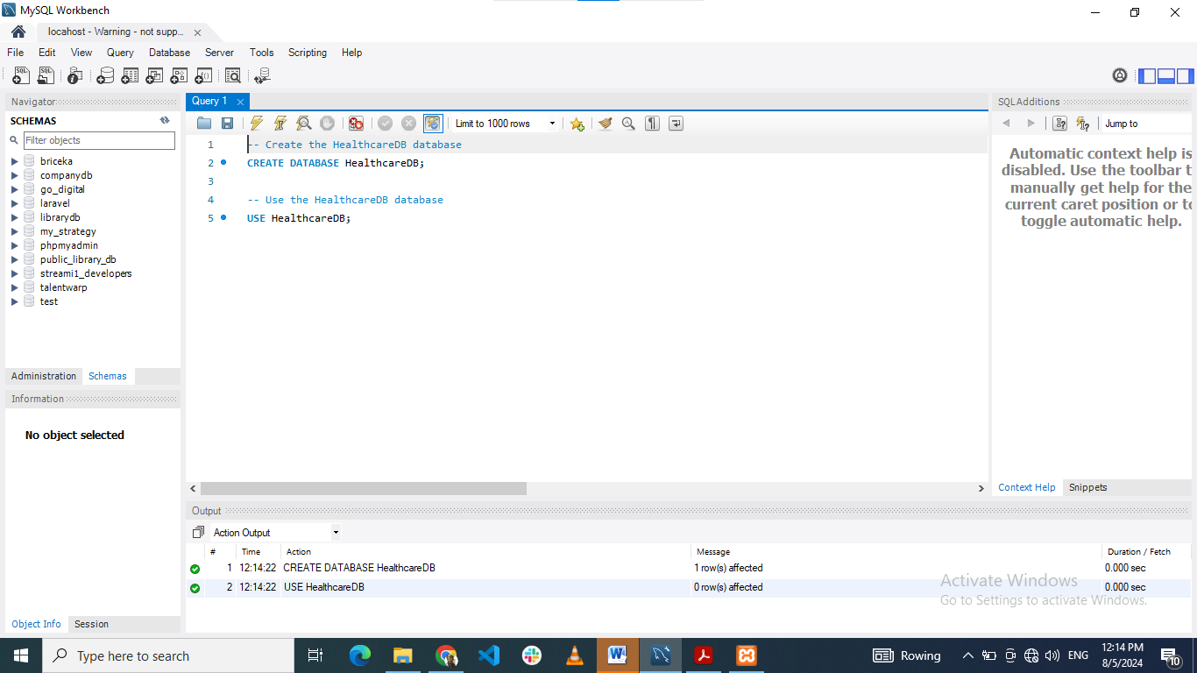

Title: creating HealthcareDB database using MYSQL workbench

## Tables

### PatientsInfo table

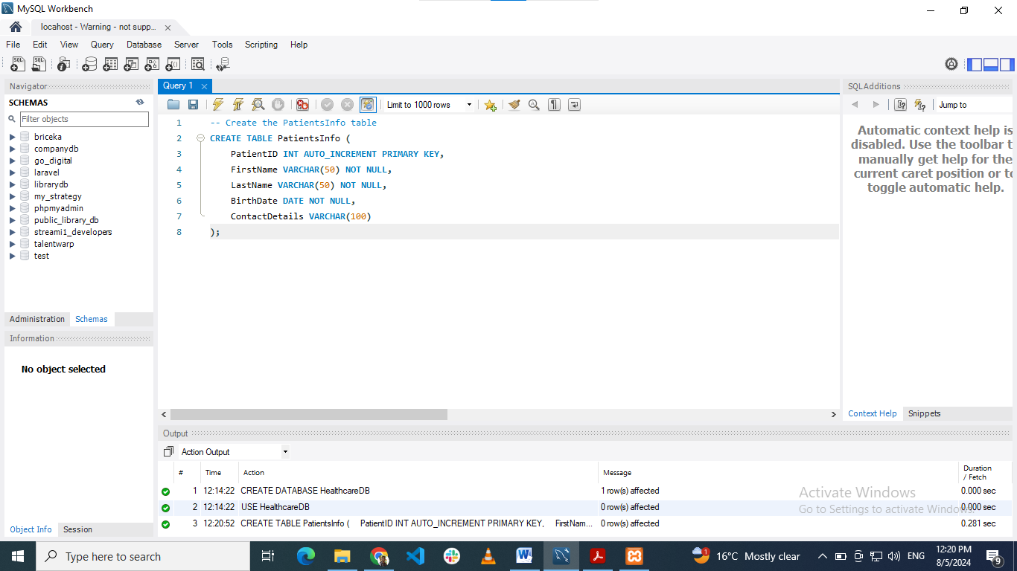

Title: creating PatientsInfo table using MYSQL workbench

#### Significance

Significance: It contains the main data entry of all patient information. Basic data like the patient’s identification number, personal name and surname, date of birth and communication details are outlined. This table focuses on the more efficient way of handling patient records and all the records of the patients are compiled in one central location, and therefore any details can be easily retrieved by medical practitioners and other personnel.

### DoctorsInfo

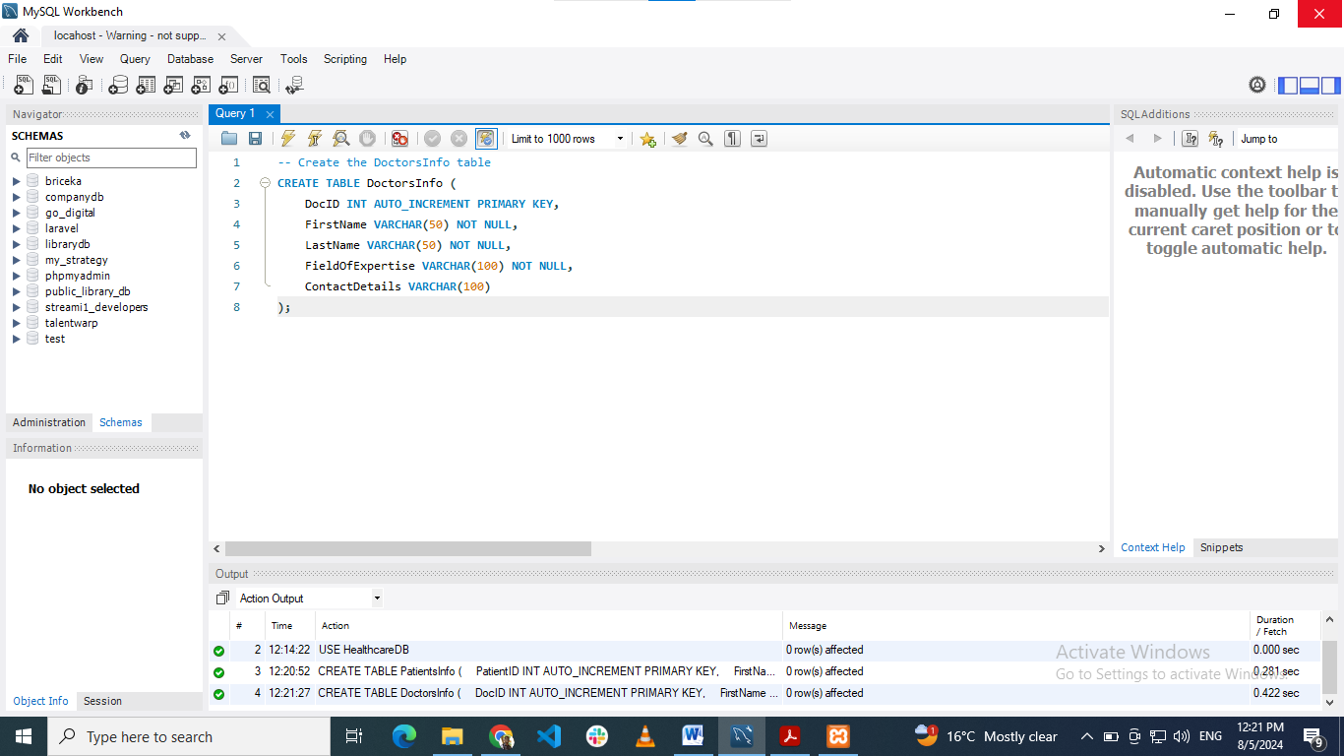

Title: creating DoctorsInfo table using MYSQL workbench

#### Significance

The table, DoctorsInfo contains detailed information about the doctors and other health care providers such as the doctor’s identification number, their names, the line of specialization and their contact information. This table aids in the administration of doctor data stored in the system, and makes it easier to sort through. Through the data base, it leads to correlation of doctors with their appointments and records in the provision of health care services.

### Schedules

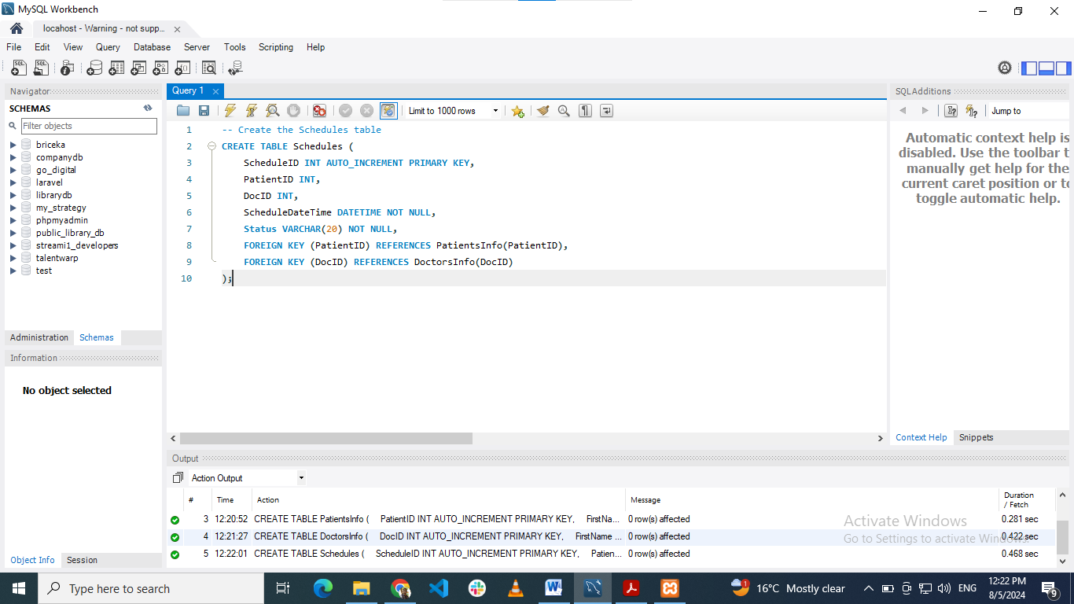

Title: creating Schedules table using MYSQL workbench

#### Significance

This table is used to record appointment and other related scheduling. Some of the components parts of the appointment include appointment ID, patient ID, doctor ID, date/time to appointment and the status. Schedule: This table is so vital in a system because patient appointments, and healthcare services schedule and follow-up are crucial in a healthcare system.

### HealthRecords

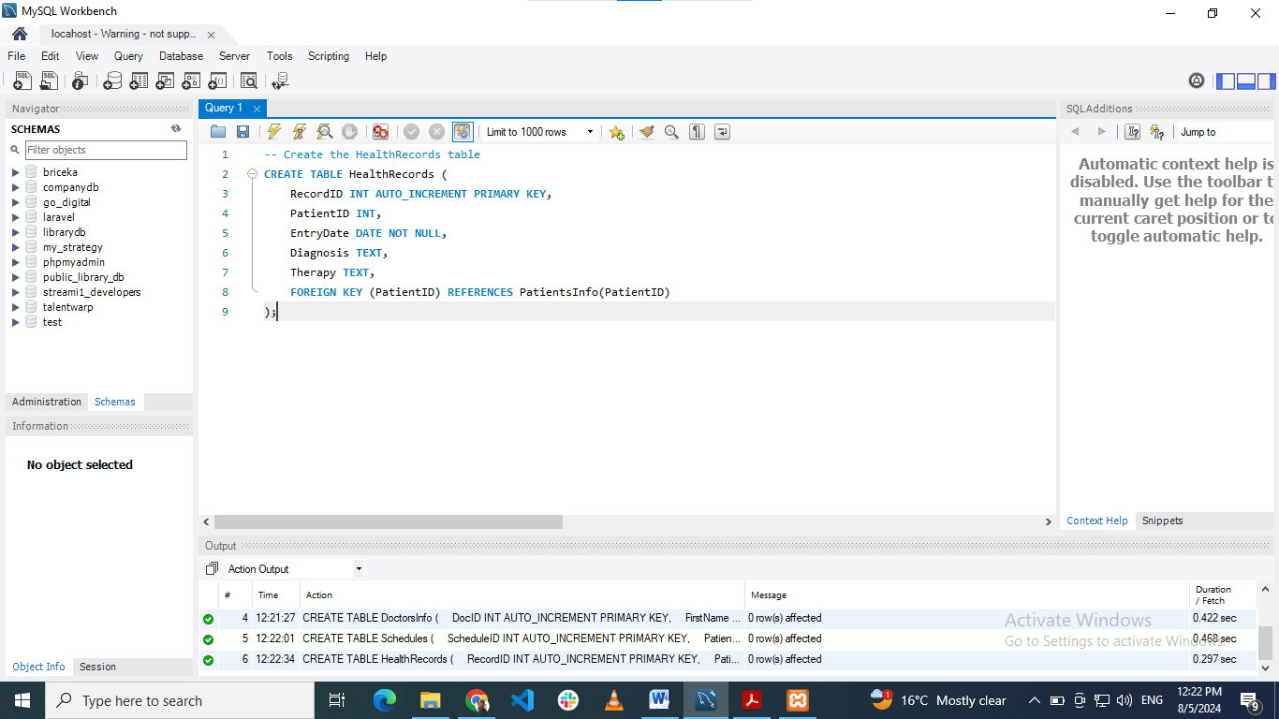

Title: creating HealthRecords table using MYSQL workbench

#### Significance

HealthRecords Table stores information that belongs to patients’ history of their Health. It contains data on the diseases, the measures prescribed for them, and the date of the creation of the medical records. The table is essential for addressing health records containing patient’s medical history which is an important factor in constant care.

### Pharmaceuticals

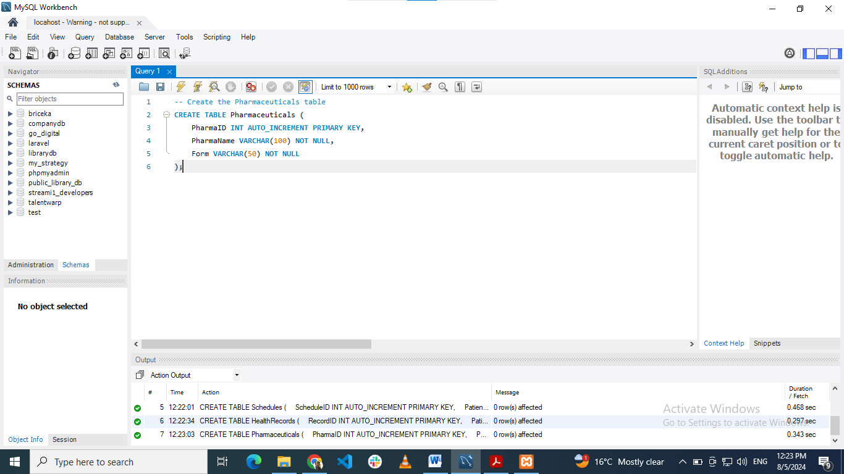

Title: creating Pharmaceuticals table using MYSQL workbench

#### Significance

Table of Medication: This table has details of medications, they may include such fields as medication ID, medication name or form, it may include tablet, capsule and others. It provides the index to all the medications existing in the system. A record of the various pharmaceuticals is made easy through the table which aids in prescriptions and dispensing of drugs.

### PrescribedMeds

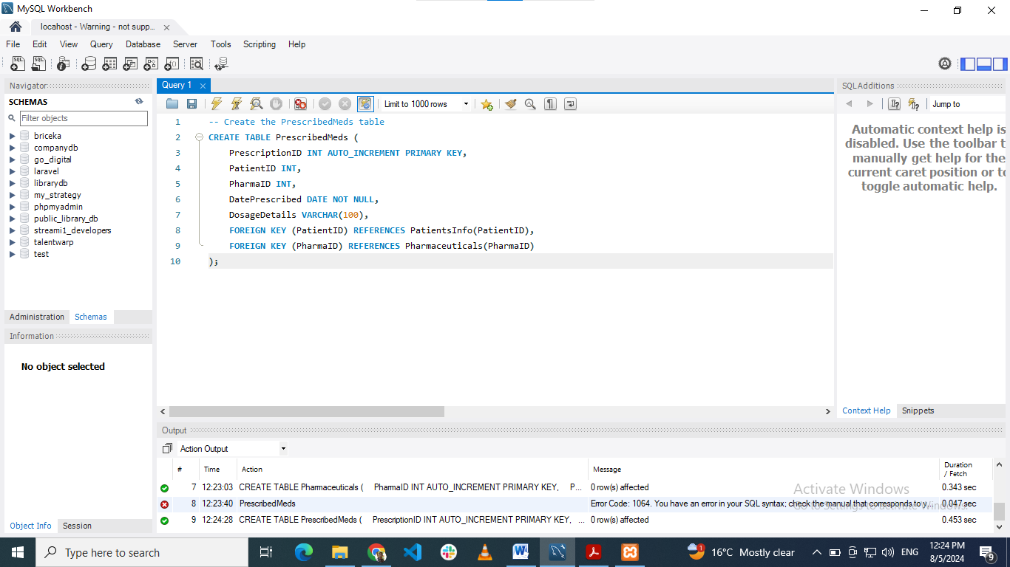

Title: creating PrescribedMeds table using MYSQL workbench

#### Significance

The PrescribedMeds table monitors the prescriptions given to patients, this table might contain more columns as the one illustrated below. Some of the information which the program captures includes prescription ID, patient ID, medication ID, date of prescription and the details of dosage. This table is crucial in the administration and monitoring of medication orders, guaranteeing that the correct drugs and their quantities are given to the patient as per the physician’s prescription.

## Inserting Sample Data

### PatientsInfo Table

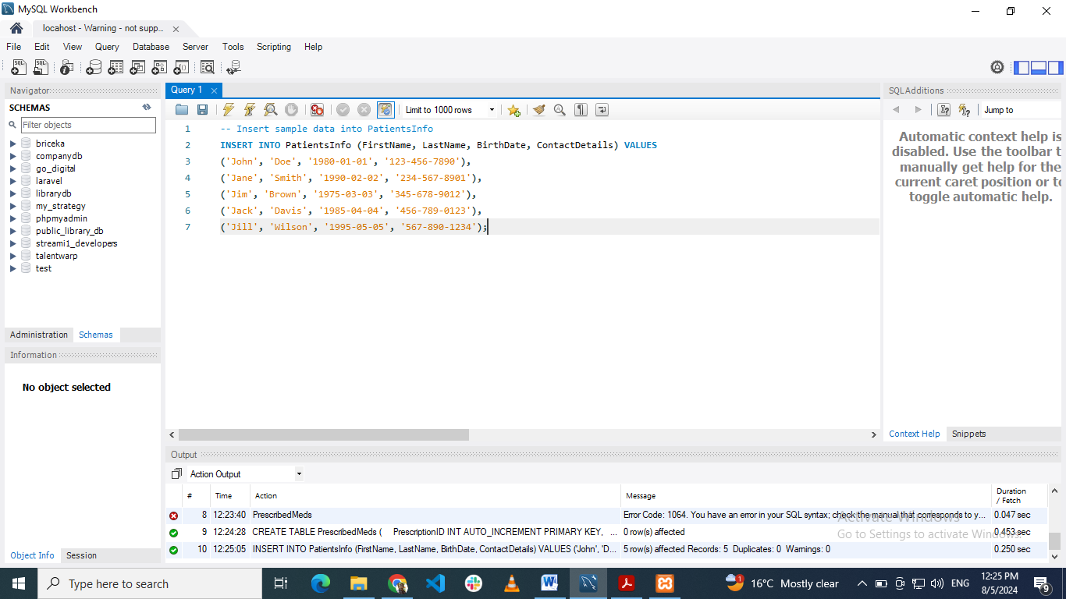

Title: Inserting data into PatientsInfo table using MYSQL workbench

### DoctorsInfo

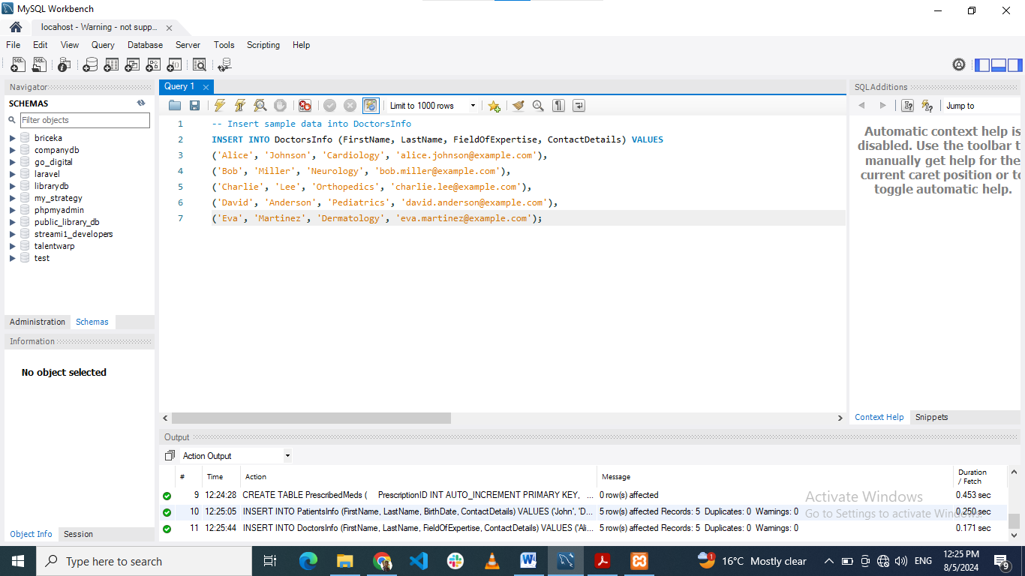

Title: Inserting data into DoctorsInfo table using MYSQL workbench

### Schedules

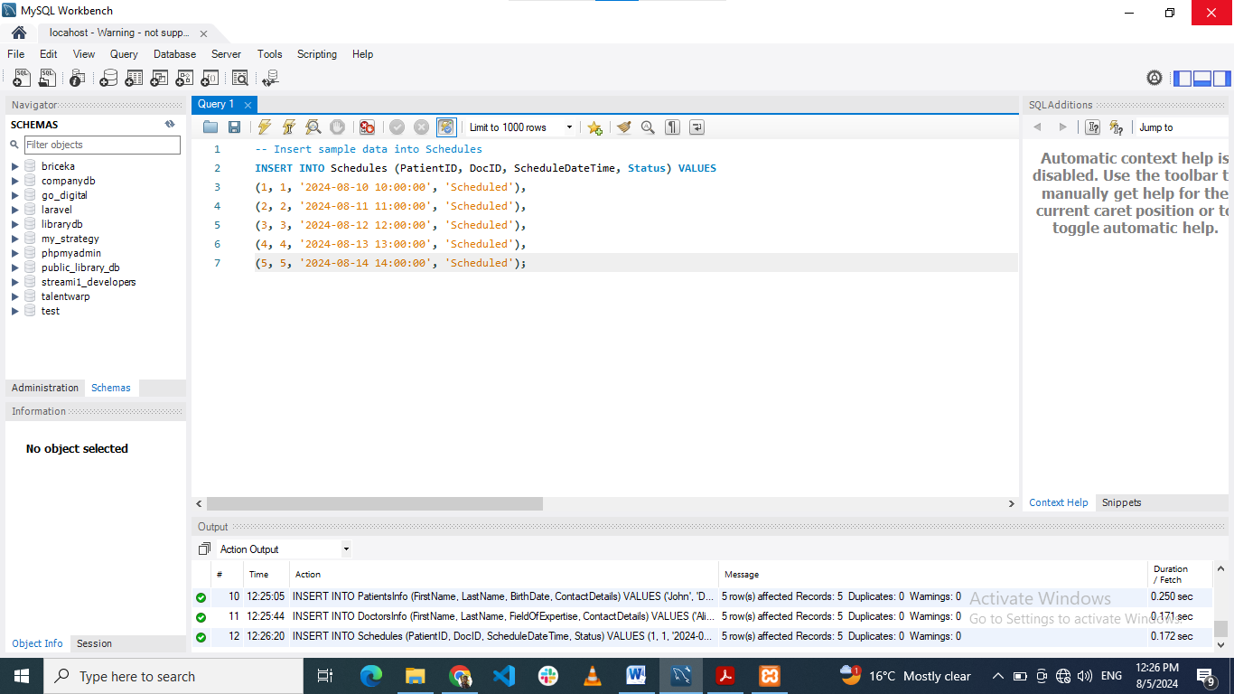

Title: Inserting data into Schedules table using MYSQL workbench

### HealthRecords

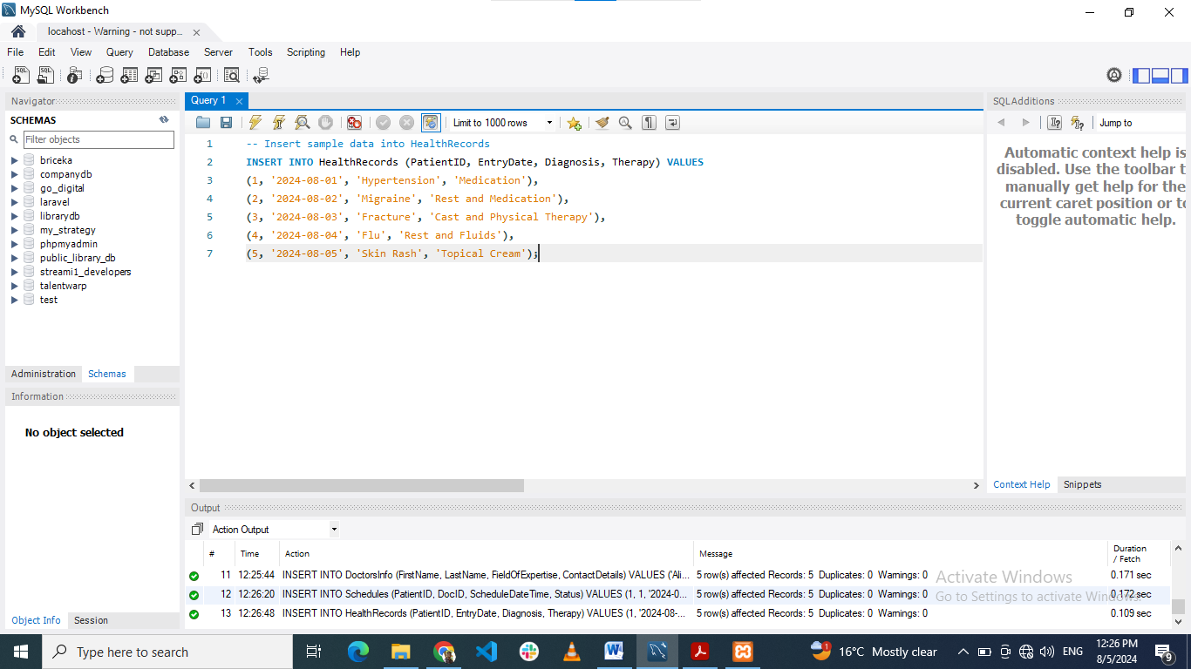

Title: Inserting data into HealthRecords table using MYSQL workbench

### Pharmaceuticals

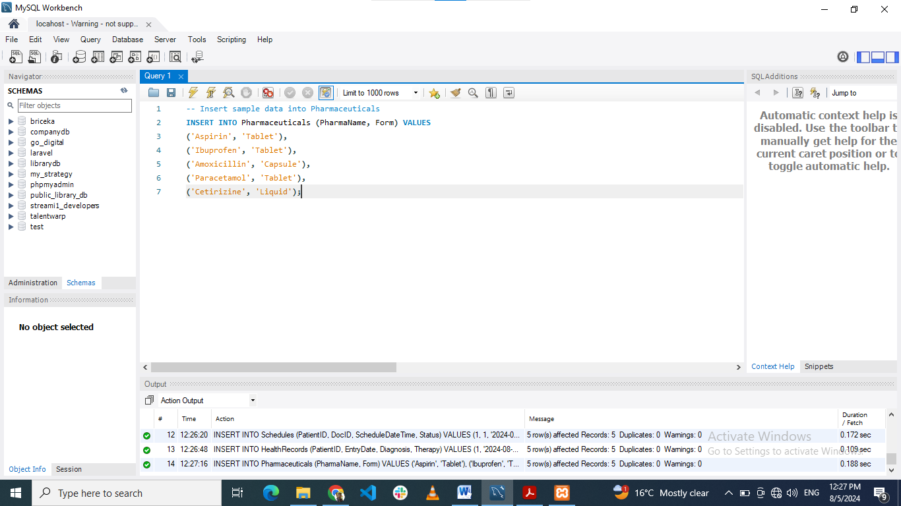

Title: Inserting data into Pharmaceuticals table using MYSQL workbench

### PrescribedMeds

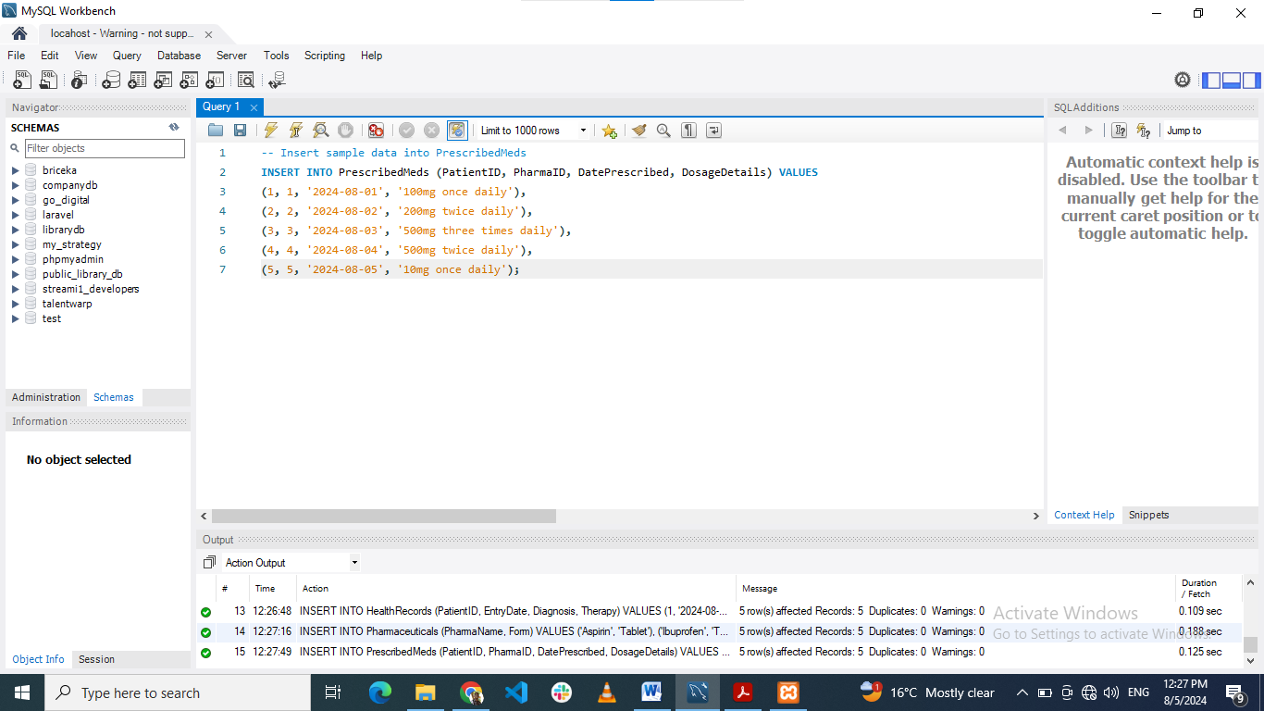

Title: Inserting data into PrescribedMeds table using MYSQL workbench

Every table is well developed to meet certain requirements concerning the manageability of health care related data. Combined, they build up a data base structure that enables good data processing, merging and querying. The linkage/association of these tables ensures that data is well categorized, for easy access and management of the healthcare data.

# Query Implementation and Analysis

In this section, we will perform actual implementation of various SQL statements, which are needed to work with the created `HealthcareDB` database. Most of the queries will be concerned with functions directly related to the collection and consumption of healthcare data services such as next appointments, patients’ medication details, and the business aspects.

## Queries

### Upcoming Week's Appointments

To display all appointments that are planned for the following week, the query must fetch from the Schedules table the ones where ScheduleDateTime is less than 7 days from today’s date.

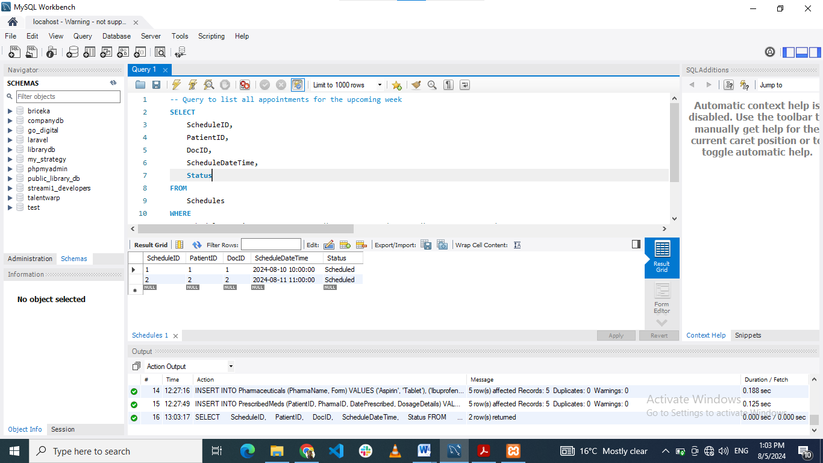

Title: SQL query to retrieve upcoming week's appointments in MYSQL workbench

#### Analysis

This query is very useful in that it allows the people working in healthcare centers to know all the appointments the next one week. Consistently, planning through the framework is helpful when predicting and allocating resources.

### Patients Prescribed Specific Medication

In order to identify all patients who were prescribed a particular drug, one would need to cross-reference the results in the PrescribedMeds table with the PatientsInfo table and use a specific PharmaID as the search criterion.

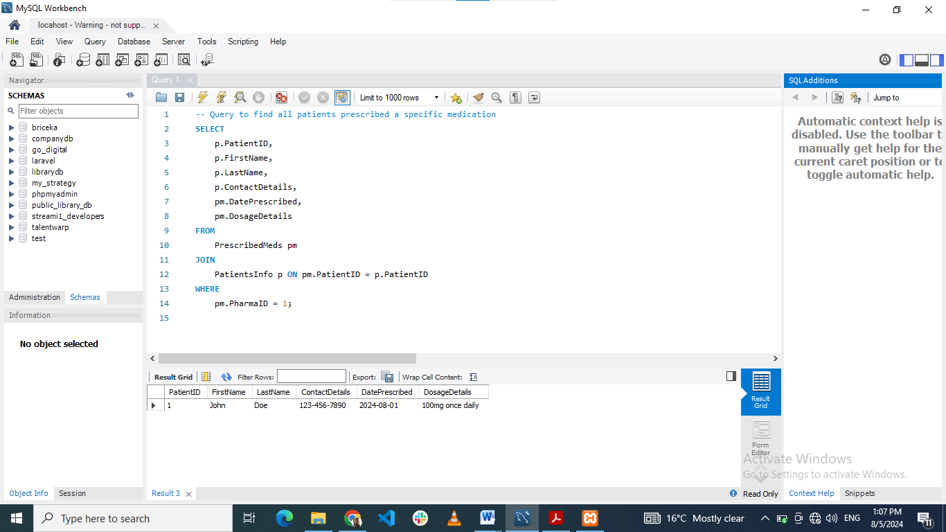

Title: SQL query to retrieve patients prescribed specific medication where PharmaID=2 in MYSQL workbench

#### Analysis

The idea of this query is to know who of the patients is using a definite medication and help healthcare providers monitor the outcomes of the medication administration.

### Doctors and specialties table

To retrieve all the doctors along with their specialties we address the DoctorsInfo table.

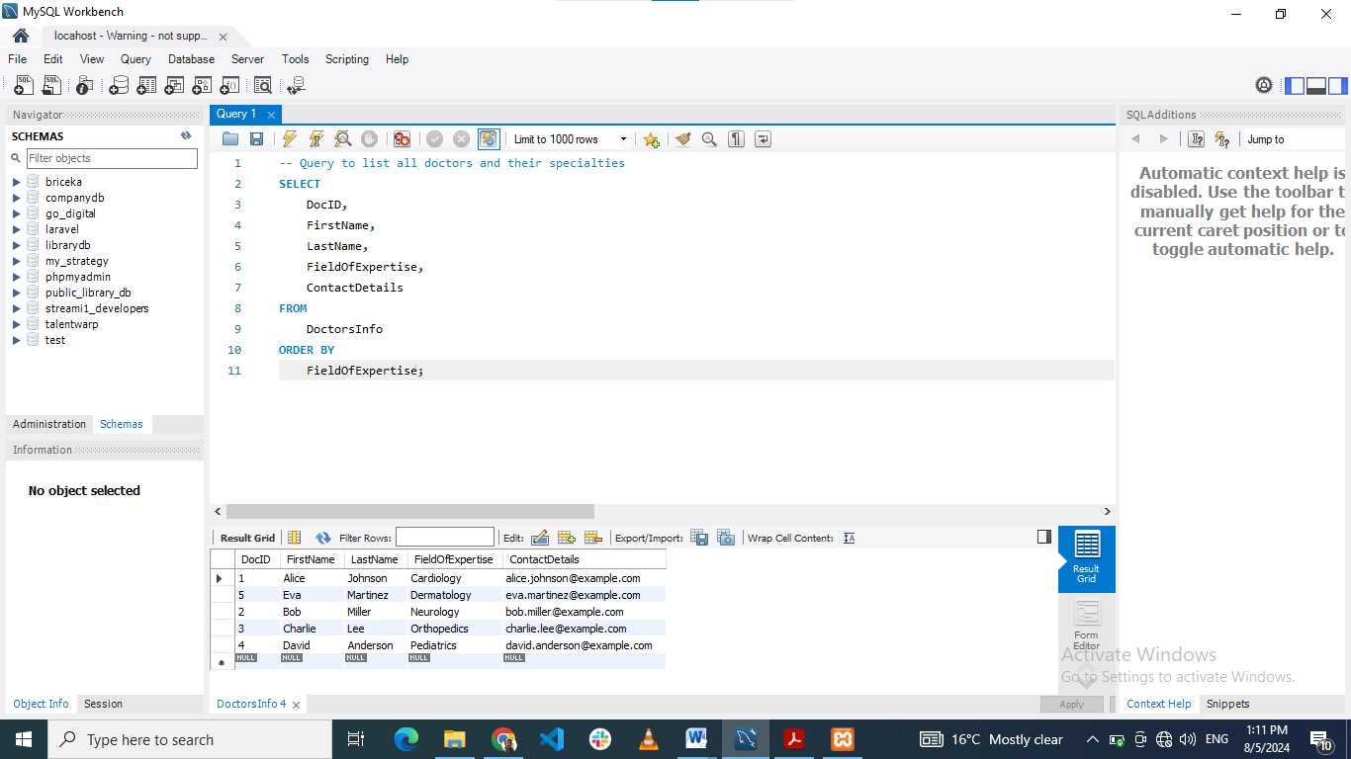

Title: SQL query to retrieve doctors and specialties data in MYSQL workbench

#### Analysis

This query refers to the list of doctors with their specialty which is useful for advocating for the patients and achieving organization directory purpose.

## Queries for Business Analytics related tasks.

### Average Number of Appointments per Doctor

The Schedule table shall also be used to calculate the average number of appointments each doctor has by grouping it by the DocID variable.

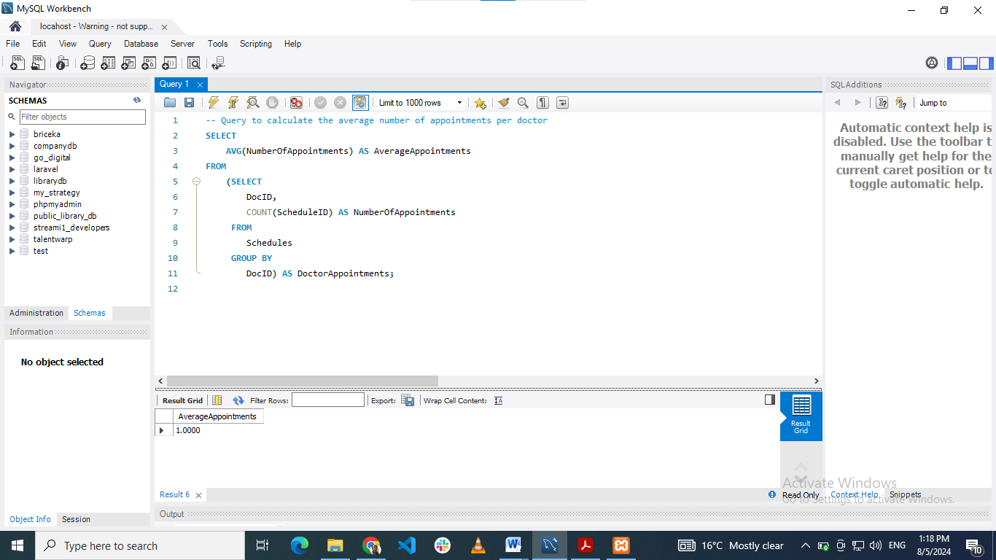

Title: SQL query to calculate the Average Number of Appointments per Doctor in MYSQL workbench

### Top 3 Most Commonly Prescribed Medications

The PrescribedMeds table is queried to identify which medications are being prescribed most often; the count(*) function is used for this task.

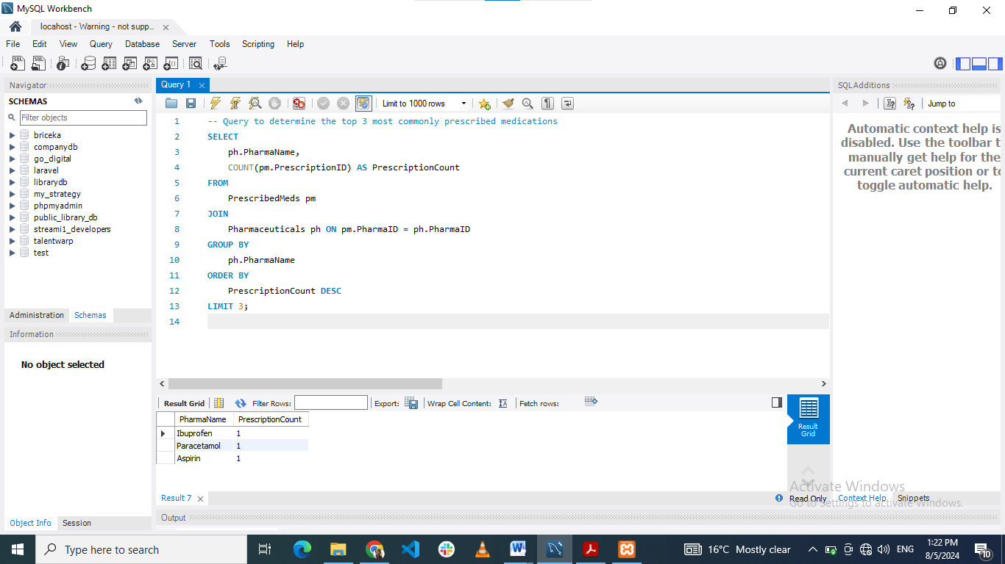

Title: SQL query retrieve most commonly prescribed medications in MYSQL workbench

#### Analysis

This query provides details of those drugs that are frequently used, which helps the organization to know the usage of drugs and assists in stocking the common ones.

### Monthly Report of New Patients

To achieve the objective of having a monthly report of newly added patients in the system over the past one year, patient counting needs to be based on the time of addition.

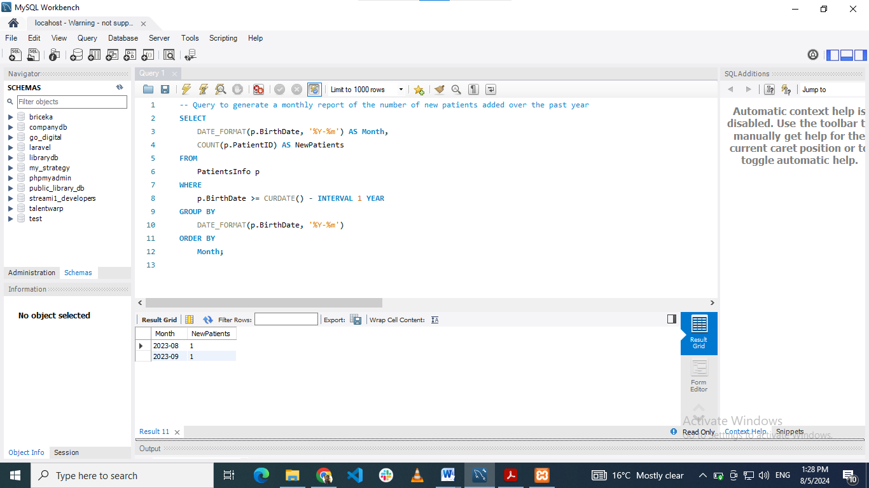

Title: SQL query calculate monthly reports on new patients in MYSQL workbench

#### Analysis

Although this query does not show the specific date the patients joined the program, it enables one to see how the enrollment variation over the year and whether the program has been effective in its outreach.

Every question is aimed at capturing what McEachen et al regard as critical factors in the management of healthcare information and its application to servicing the healthcare system for both operational and tactical purposes.

# Conclusion

## Summary

In this particular report, it was possible to illustrate the creation, development as well as the evaluation of the constructed database and its application in the health care environment utilizing MySQL. The activities included coming up with the proper design of the tables, as well as inputting sample records, and running queries to obtain important information.

## Key Findings

### 1. Database Design:

Database was created using a comprehensive schema consisting of multiple interconnected tables. Every table that has been constructed incorporated correct primary and foreign keys to help in data integrity as well as data selection and manipulation.

### 2. Implementation:

The formation of the database and the tables was successful and sample data was also entered into the tables. Real values were used in the sample data so that the query result will be as accurate as the actual data gathered from the field.

### 3. Query Analysis:

Various SQL queries were crafted to extract meaningful information from the database. Upcoming Week’s Appointments provided a list of appointments that had been made for the week to come.

- Patients Prescribed Specific Medication: Concluded patients who were on a certain drug.

- List of Doctors and Specialties: List down the enumerated doctors as well as their fields.

- Average Number of Appointments per Doctor: Determined the ratio per doctor appliance of the physicians having appointments.

- Top 3 Most Commonly Prescribed Medications: Identified the key drugs in the percentage of total prescription.

- Monthly Report of New Patients: Prepared a report of the monthly new patients’ admission and evaluate the report for the past one year.

### Challenges and Solutions

- Data Accuracy: Initially, the queries used the sample data, which were out-dated, and the result was a ‘blank’ screen. This was done by replacing the data with up to date information which complied with the specifications of the queries.

- Query Optimization: Modifications were made to queries to have corrected counting and averaging, this was done by simplifying sub queries.

Through this case of a successfully implemented system for a healthcare database, it is evident that the design and especially the query processes ensuring effective management and analysis of healthcare data call for proper design and query execution. Of course, the described lessons help avoid some pitfalls when designing more intricate and loaded database systems in the future.